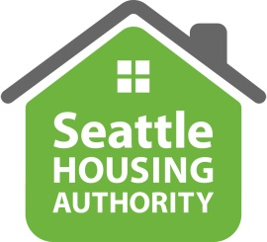

 | Address  Telephone  TDD  Website | 101 Elliott Avenue W,  Suite 100, Seattle WA, 98109  206–615-3300  1-800-833-6388  www.seattlehousing.org

MINORITY/WOMEN OWNED BUSINESS ENTERPRISE SELF-IDENTIFICATION FORM for
WORK PERFORMED ON SEATTLE HOUSING AUTHORITY PROJECTS

Please complete the following information to be included in your business profile to be posted on
Seattle Housing Authority’s website. Please direct questions to Patti Armstrong at 206-615-3379.

Company Name
Doing Business As
Description of Business Services
Address
Website
Contact Person
Email
Phone Number

The undersigned acknowledges and certifies that above company meets the minority/women owned business enterprise certification requirements as defined in Washington Administrative Code (WAC) Chapters 326-02 and 326-20, as set forth in more details on the official website of Washington State Office of Minority & Women’s Business Enterprises, under the “Certification” page.
The undersigned acknowledges SHA’s rights to require the submission of additional information for purposes of verifying proof of ownership and eligibility status.

Signature of Company Officer: Date:

Printed Name and Title

