Section 3 Worker and Targeted Section 3 Worker
Self-Certification Form

_____________________________________________________________________________________________________________________________________________________________________________________________________________________________________

The purpose of HUD’s Section 3 program is to provide employment, training and contracting opportunities to low-income individuals, particularly those who are recipients of government assistance for housing or other public assistance programs. Your response is voluntary, confidential, and has no effect on your employment.

Eligibility for Section 3 Worker or Targeted Section 3 Worker Status

A Section 3 worker seeking certification shall self-certify and submit this form to the recipient contractor or subcontractor, that the person is a Section 3 worker or Targeted Section 3 Worker as defined in 24 CFR Part 75.

Instructions: Enter/select the appropriate information to confirm your Section 3 worker or Targeted Section 3 Worker status.

Employee Name: _______________________________

- Are you a resident of public housing or a Housing Choice Voucher Holder (Section 8) | YES NO
- Are you a YouthBuild participant? | YES NO
- Check the box for the county where you reside.

King County Pierce County Snohomish County Other ________________
- In the field below, select the amount of individual income you believe you earn on an annual basis.

Less than $10,000 $30,000 - $40,000 More than $60,000
$10,001 - $20,000 $40,001 - $50,000
$20,001 - $30,000 $50,001 - $60,000

Select from ONE of the following two options below:

I qualify as a:

Section 3 Worker (as defined on page 3 of this Section 3 Worker Certification Form)

Targeted Section 3 Worker (as defined on page 3 of this Section 3 Worker Certification Form)

________________________________________________________________________

Employee Affirmation

I affirm that the above statements (on page 1 of this form) are true, complete, and correct to the best of my knowledge and belief. I hereby certify, under penalty of law, that the following information is correct to the best of my knowledge.

Employee Address: ___________________________________________

Print Name: _____________________________________

Signature: ______________________________________ Date: __________

FOR ADMINISTRATIVE SE ONLY

Is the employee a Section 3 worker based upon their self-certification? YES NO

Is the employee a Targeted Section 3 worker based upon their self-certification? YES NO

Was this an applicant who was hired as a result of the Section 3 project? YES NO

If Yes, what is the name of the company? ____________________________

What was the date of hire? ______________

EMPLOYERS MUST RETAIN THIS FORM IN THEIR SECTION 3 COMPLIANCE FILE FOR FIVE YEARS.

The Housing Authority of the City of Seattle

Section 3 Income Limits Eligibility Guidelines

The worker’s income must be at or below the amount provided below for an individual regardless of actual household size.

King and Snohomish Counties
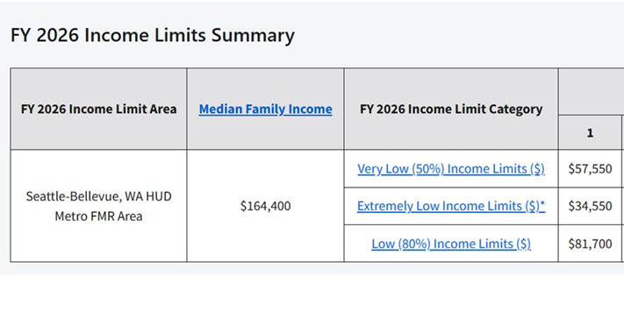
Pierce County
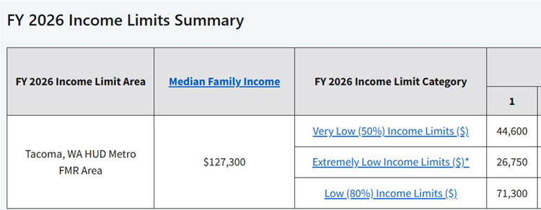

Tables above are for reference only. Check HUD website 2026 Income Limits Dataset | Summary for most recent income limits.

Section 3 Worker Definition:

- A low or very low-income resident (the worker’s income for the previous or annualized calendar year is below the income limit established by HUD); or
- Employed by a Section 3 business concern; or
- A YouthBuild participant.

Targeted Section 3 Worker Definition:

- Employed by a Section 3 business concern; or
- Currently fits at least one of the following categories as documented within the past five years:
- A resident of Seattle Housing Authority public housing or Section 8-assisted housing;
- A resident of other public housing projects or Section 8-assisted housing managed by the public housing authority that is providing the assistance; or
- A YouthBuild participant.

